Final Project

Home page



Staff Page

Annual Page

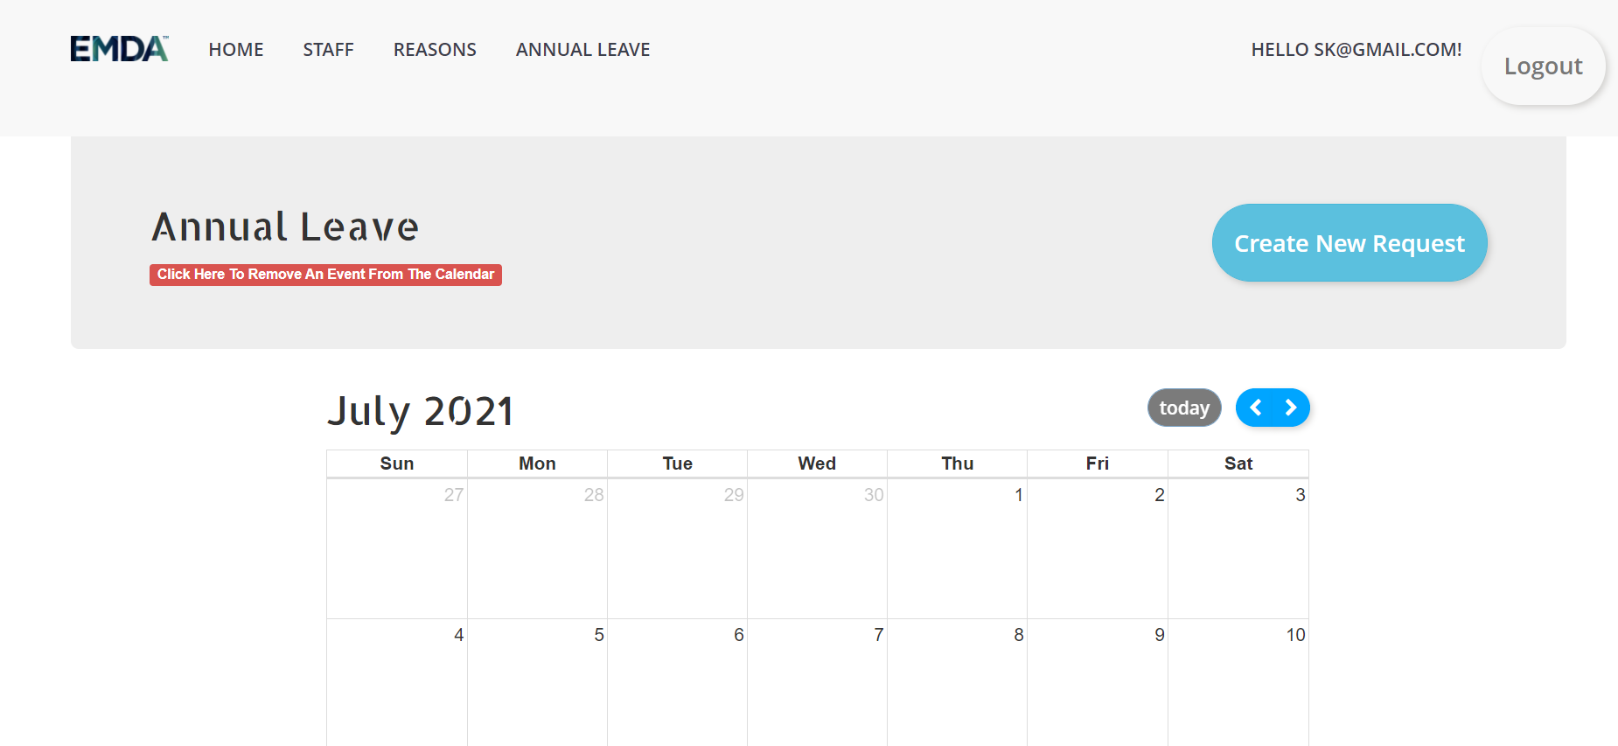

Login Page

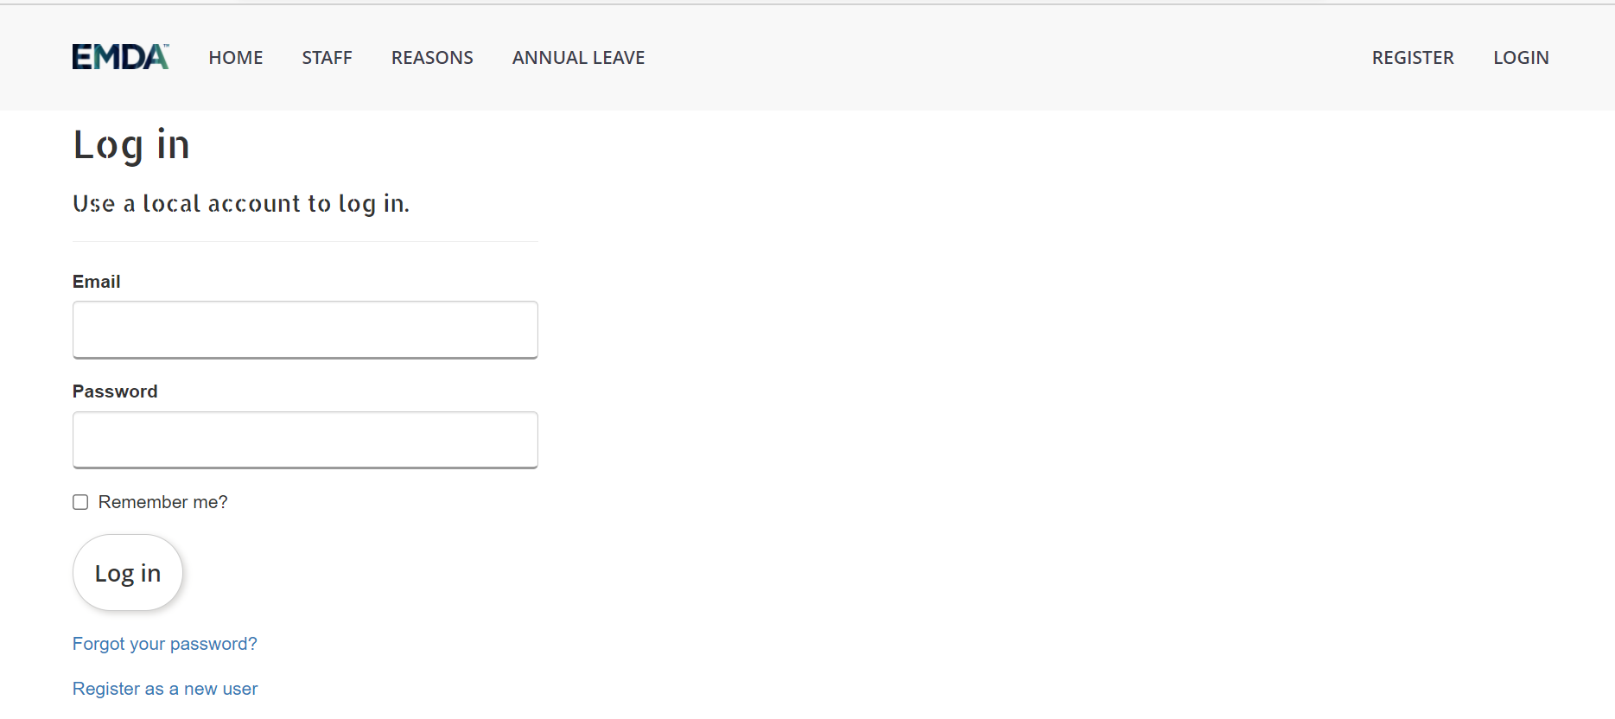

Register Page

